Mongodb Journal notes:

Macintosh HD:Users:dc:Desktop:Screen Shot 2012-09-07 at 2.53.20 PM.png

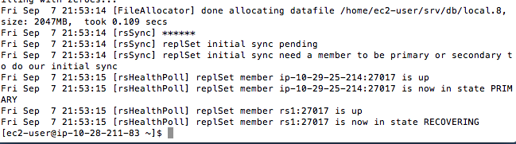

Macintosh HD:Users:dc:Desktop:Screen Shot 2012-09-08 at 6.56.06 PM.png

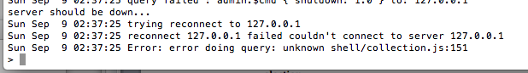

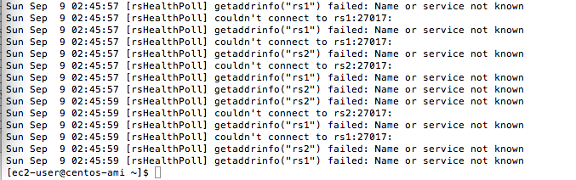

Macintosh HD:Users:dc:Desktop:Screen Shot 2012-09-08 at 10.25.50 PM.png

Macintosh HD:Users:dc:Desktop:Screen Shot 2012-09-08 at 10.26.06 PM.png

Macintosh HD:Users:dc:Desktop:Screen Shot 2012-09-08 at 10.41.46 PM.png

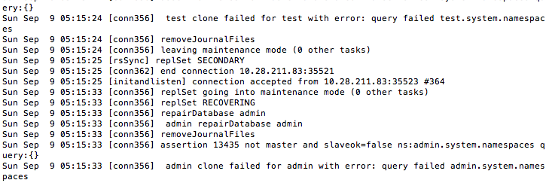

Macintosh HD:Users:dc:Desktop:Screen Shot 2012-09-08 at 10.42.32 PM.png

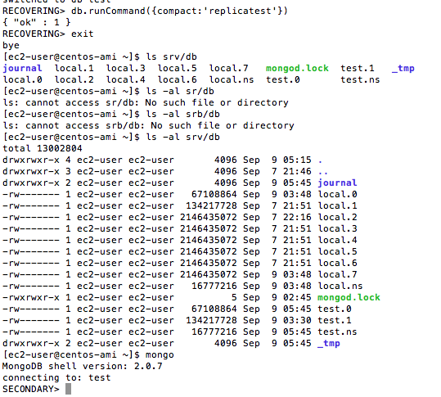

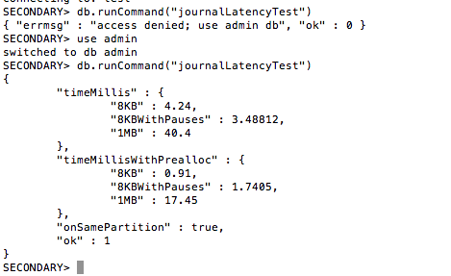

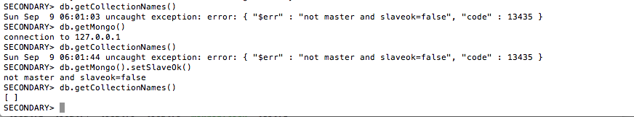

Macintosh HD:Users:dc:Desktop:Screen Shot 2012-09-08 at 11.02.44 PM.pngMacintosh HD:Users:dc:Desktop:Screen Shot 2012-09-08 at 11.02.51 PM.png

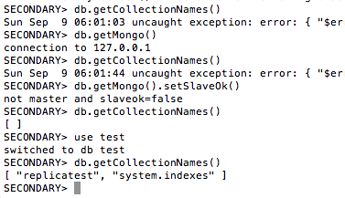

Macintosh HD:Users:dc:Desktop:Screen Shot 2012-09-08 at 11.03.56 PM.png

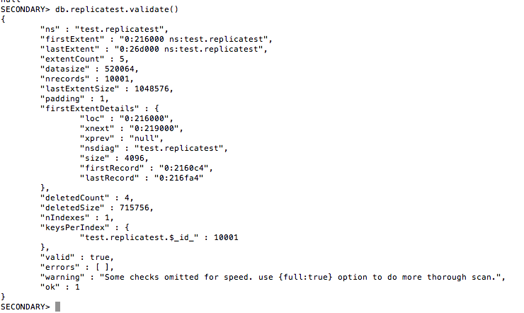

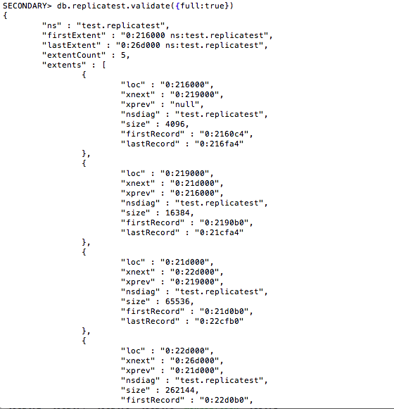s